Electron-Ion Collider, Requirements, Specifications, and Interfaces
Interface Control Document: [###]
Hadron Polarimetry Systems (6.03.01.11.02) to ASR Hadron Storage Ring (6.02.03)

Prepared by:
{{Sig_es_:signer1:signature}} Date: {{Dte_es_:signer1:date}}
Name, Role
Electron-Ion Collider at Institution

Reviewed by:
{{Sig_es_:signer2:signature}} Date: {{Dte_es_:signer2:date}}
Name, Role
Electron-Ion Collider at Institution

{{Sig_es_:signer3:signature}} Date: {{Dte_es_:signer3:date}}
Name, Role
Electron-Ion Collider at Institution

{{Sig_es_:signer4:signature}} Date: {{Dte_es_:signer4:date}}
Name, Role
Electron-Ion Collider at Institution

Approved by:
{{Sig_es_:signer5:signature}} Date: {{Dte_es_:signer5:date}}
Name, Role
Electron-Ion Collider at Institution

REVISION HISTORY
Revision # | Effective Date | Additional Reviewers | Summary of Change
00 |  |  | Initial release.

TABLE OF CONTENTS
1. Purpose and Scope 5
2. Introduction 5
2.1 Hadron Polarimetry Systems 5
2.2 Overview of Interface Relationships 9
2.3 Safety and Environmental Considerations 9
2.4 Design Considerations 10
2.5 Organization 10
3. Interface summary 10
4. Hadron Polarimetry Systems (DET-POL-HPOL) to ASR Hadron Storage Ring (ASR-HSR) 12
5. Applicable Documents 14
6. Detailed change Log 14
7. References 14

LIST OF ACRONYMS
B0 | B0 is the name of the forward magnet just past the Hadron Endcap
CDR | Conceptual Design Report
COTS | Commercial Off the Shelf
DAQ | Data Acquisition
DET | EIC Detector
DIRC | Detection of Internally Reflected Cherenkov Light
dRICH | Dual radiator ring imaging Cherenkov
DVCS | Deeply Virtual Compton Scattering
EIC | Electron-Ion Collider
EMCAL | Electro-magnetic Calorimeter
ESR | Electron Storage Ring
FCC | Federal Communications Commission
FDR | Final Design Review
GEM | Gas Electron Multiplier
HCAL | Hadronic Calorimeter
HSR | Hadron Storage Ring
HVAC | Heating/Ventilation/Air Conditioning
IP | Interaction Point
IR | Interaction Region
MPGD | Micro Pattern Gaseous Detectors
NAS | National Academy of Sciences
NEC | National Electric Code
NEMA | National Electrical Manufacturers Association
NFPA | National Fire Protection Association
NRTL | Nationally Recognized Testing Laboratory
PID | Particle Identification
PRR | Production Readiness Review
PWO | PbWO4
RCS | Rapid Cycling Synchrotron
TBD | To Be Determined
UL | Underwriter Laboratories
WBS | Work Break Down Structure

Interface Control Document:
Hadron Polarimetry Systems (6.03.01.11.02) to ASR Hadron Storage Ring (6.02.03)

Purpose and Scope
This document records the agreed upon interfaces between the Hadron Polarimetry Systems and other sub-systems within the ASR Hadron Storage Ring, specifically the hydrogen-jet polarimeter (HJET) and the proton-Carbon (pC) polarimeters. These two instruments will be located in IP4, and an additional pC polarimeter will be deployed in the interaction region. These interfaces are based on the system requirements that are necessary to integrate these sub-systems as part of the Electron Ion Collider Project.

Introduction
These interfaces describe the relationships between the Hadron Polarimetry Systems and the ASR Hadron Storage Ring including (examples by inclusion) located in (areas by inclusion).

Hadron Polarimetry Systems
The physics program of an EIC requires that both beams, electrons and light hadrons, are polarized. To measure the polarization requires high precision polarimetry. This document discusses the hadron polarimetry in the hadron storage ring (HSR) of the EIC.
There are three types of polarimeters in the HSR
An absolute polarimeter using a polarized hydrogen jet target (HJET), see Figure 1.
Two fast proton-carbon (pC) polarimeters giving relative polarization measurements and determining the polarization profile as well as the polarization lifetime through a fill, see Figure 2.
A local pC polarimeters in the interaction between the spin rotators to measure the spin orientation in the transverse (xy-plane) at the main detector.
The fast polarimetry will be based on very small angle polarized proton-carbon (pC) elastic scattering in the Coulomb-Nuclear Interference (CNI) region. Typically, $50-100∙{10}^{6}$ events are collected in $30 s$, giving a ç relative uncertainty measurement of the beam polarization per sweep of the thin carbon fiber across the beam. Zero dead time readout is desirable to record the data. The pC polarimeters (see Figure 1) will provide the polarization normalization for the experiments for each fill. Measurements before and after the acceleration ramp are used to quantify the polarization loss, particularly during studies of beam acceleration to the highest energies. i.e, $100$ and $275 GeV$. Measurement will be made every 2-3 h throughout a EIC fill, providing the polarization lifetime. Each measurement sweeps of the carbon ribbon target across the beam provides the transverse polarization profile.
Carbon fiber targets with the most robust specifications, as learned from experience from RHIC, will be reused after upgrades. The target holders will be produced from a non-conducting material (e.g., Al2O3) to reduce electromagnetic wake fields in the scattering chamber. To avoid the requirement for breaking the vacuum to install the carbon ribbon targets, the pC target chamber system will be redesigned to incorporate a vacuum transfer chamber.
The hydrogen‐jet polarimeter employs a polarized atomic hydrogen beam to set the absolute polarization scale via a Breit–Rabi polarimeter, while relative asymmetries between target and beam spin states are used to determine the beam polarization. The precision is statistically limited by the target thickness, yielding about 3-4% statistical uncertainty per typical 8-hour fill.
For operation at the Electron-Ion Collider, the HJET (see Figure 2) must undergo substantial upgrades to maintain its role as the absolute polarization standard. The most critical modification concerns the holding-field system: the magnetic field strength needs to be increased from roughly $120 mT$ to about $400 mT$ to shift the atomic transition frequencies above beam harmonics and suppress beam-induced depolarization. As an initial, first-order implementation, a vertical ($B_{y}$) configuration at the higher field level is sufficient to measure the vertical polarization component ($P_{y}$); however, the mechanical and magnetic layout should already be prepared for a later upgrade to a fully flexible vector guide-field system providing switchable $\vec{B}=(B_{x},B_{y},B_{z})$ components, allowing rotation of the target quantization axis along any Cartesian direction.
The detector system must also be modernized to accommodate bunch-by-bunch operation, with increased azimuthal acceptance and finer segmentation to preserve full recoil coverage and enable the separation of $\sin{φ}$ and $\cos{φ}$ harmonics at small momentum transfer ($|t|$). In parallel, the Breit-Rabi polarimeter will be upgraded with a quadrupole mass analyzer to continuously monitor the 3-4% molecular-hydrogen admixture, enabling accurate determination and correction in the polarization analysis of the resulting dilution. To integrate the stronger holding field, compensation coils, and associated services, the installation must include a pit of roughly three-quarters of a meter below the jet chamber. Collectively, these measures are expected to yield a statistical precision of about 3 % per 4-hour integration and an absolute systematic uncertainty better than 1 %, meeting the EIC performance goals.

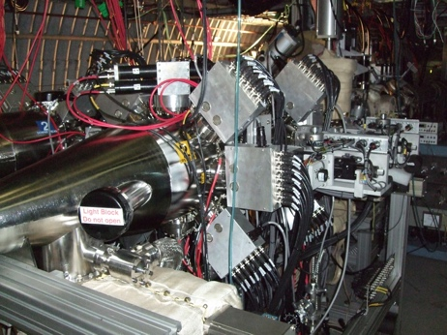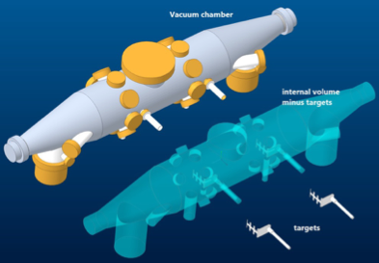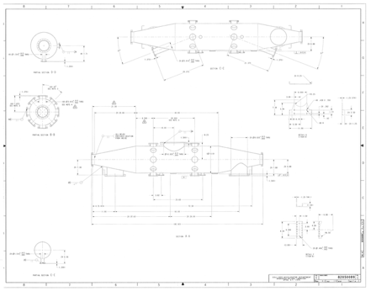
- One of the pC polarimeter vacuum chambers presently used in RHIC with in-beam target ladders installed inside the beam pipe. Two target holders that are moved horizontally and two are moved vertically; the chamber can hold 4 ×6 carbon-ribbon targets in total. One pC polarimeter will be place in IP4 of the HSR of EIC, and one in IP6 between the spin rotators.

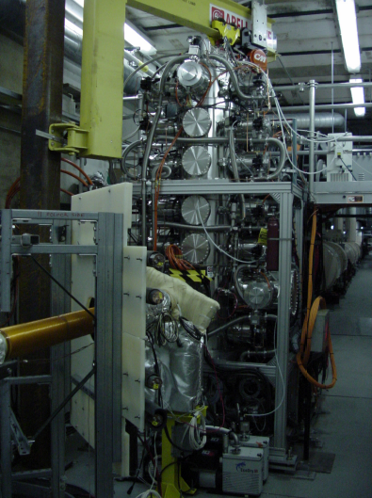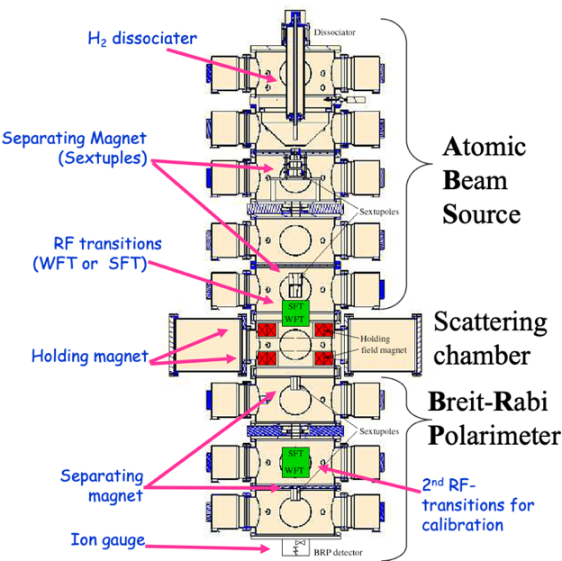
- Shown here is the RHIC HJET, which after modifications and upgrades, will be placed in IP4 of the HSR of EIC.

Measuring polarization of 3He beams additionally requires forward taggers to veto breakup of the He-3 in collisions with the H-Jet, and a dipole downstream of the H-jet to separate the breakup products: deuterons, protons and neutrons. A schematic description of the tagging setup is shown in Figure 3. The neutrons pass undeflected through the dipole; the protons and deuterons, with approximately 2/3 and 4/3 of the beam rigidity, respectively, follow different trajectories. Sufficient drift space after the dipole is required to allow placement of the taggers outside of the beampipe. An example dipole is the RHIC DX magnet. 6 m after the DX, the d, p and n would be separated from the beam by approximately 5, 7 and 15 cm, respectively.

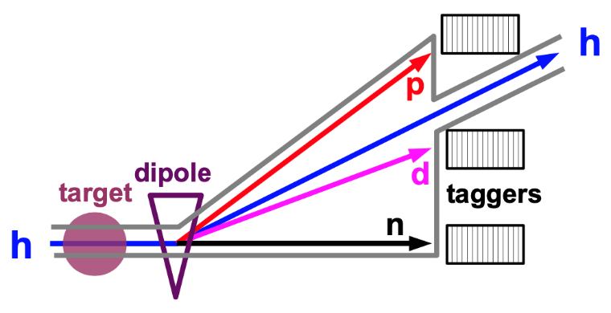
- Schematic setup of the forward tagging system to measure the He-3 breakup products d, p, and n.

All beam polarimeters will be placed close to each other to minimize the beam spin rotations between the devices.

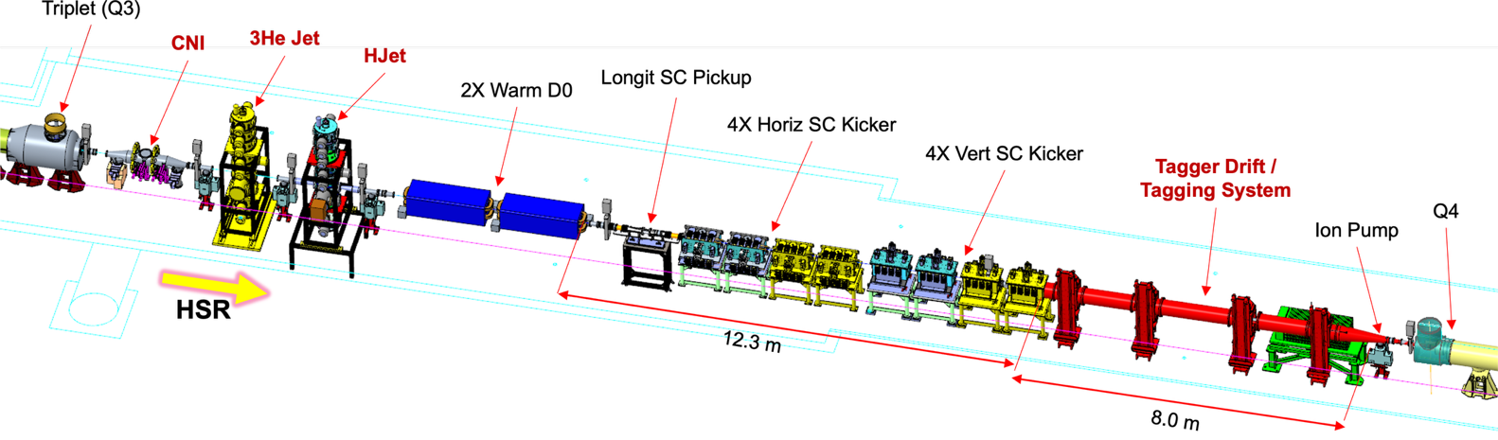
- Hadron polarimetry instrumentation concentrated at Interaction Point 4 (IP4) of the EIC high-energy storage ring (HSR). From left to right along the beam direction (yellow arrow): CNI polarimeter; ³He jet target; hydrogen-jet (HJET) polarimeter; two warm D0 dipoles; longitudinal superconducting pickup; four horizontal and four vertical superconducting kickers; HJET tagger drift/tagging system of length 8.0 m; vacuum/ion-pump section; and quadrupole Q4. Co-locating these devices in a single straight section provides shared infrastructure, common alignment, and efficient absolute/relative beam polarimetry, and minimizes spin rotations between polarimeters.

At IP4, the counting house must be located within 100 m of the polarimeters (see Figure 5). The area should house operational equipment and slow-control systems - workstations, timing/trigger distribution, and detector front-end electronics - in temperature-controlled racks with clean power (UPS), network, and low-noise grounding. Route all cabling between the ring and counting house through enclosed, weather-protected pedestrian corridors. Provision cable trays and access pull points with adequate sizing margins to accommodate future system expansion and facilitate routine maintenance procedures.

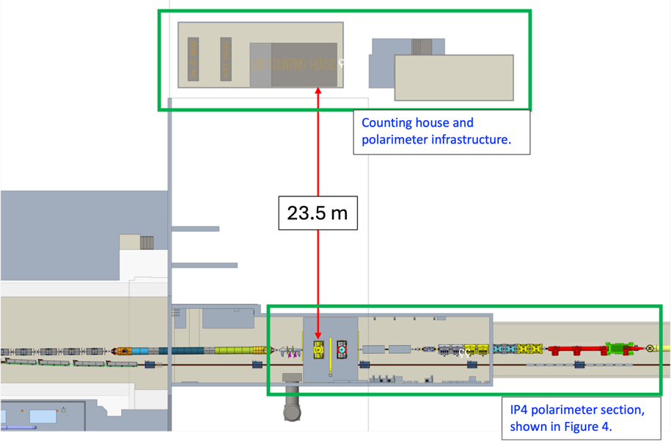
- Counting house within 100 m of the IP4 polarimeters; hosts operations and slow-control (workstations, timing/trigger, front-end) in temperature-controlled racks with clean power/network/grounding, and uses enclosed, weather-protected cable routing with trays/pull points for future upgrades.

Overview of Interface Relationships
The following are the sub-systems within the ASR Hadron Storage Ring that have interfaces connected to the Hadron Polarimetry Systems.
ASR Hadron Storage Ring (ASR-HSR): Identify the general types of interface relationships between the ICD reference system and this sub-system.

Safety and Environmental Considerations
General safety and environmental considerations are identified here. Any considerations that are specific to the individual sub-system, will be addressed in external safety documents and are referenced here.

Considerations for all systems
General environment, safety and health requirements at BNL are contained in four (4) primary source documents:
    - EIC Hazard Analysis Report - Identifies hazards, hazardous situations, and preventative and mitigative controls
    - EIC Code of Record - Design and construction requirements flow down from 10CFR851, BNL’s Worker Safety & Health Plan, and BNL’s SBMS (Standards-Based Management System)
    - EIC Integrated Safety Management Plan - Core functions and guiding principles are incorporated into EIC project processes
    - SBMS - All experimental work will be conducted in accordance with Work Planning and Control for Experiments and Operations, which ensures proper design and operation of all experiments prior to their commencement. Work Planning & Control for Experiments and Operations use the SBMS provided standard forms for the formal documentation.

Special considerations and references
Given the BNL-JLAB partnership towards EIC, supplemental EIC/JLAB MOUs exist for equipment designed, fabricated, or procured by JLAB covering:
    - Pressure System Program Integration - Documents agreement to use the TJNAF Pressure System Program for pressure systems, subsystems, and components designed, procured, or fabricated at JLAB and delivered to BNL.
    - Non-NRTL Electrical Equipment Transfer - Defines the process for transferring Non-NRTL electrical equipment designed and/or fabricated on behalf of or at JLAB to BNL.
References:
“EIC Code of Record” Document number: EIC-ORG-RSI-026
“EIC Integrated Safety Management Plan” Document number: EIC-ESH-PLN-007

Design Considerations
The physics program of EIC requires polarization of proton and light-ion beams in both longitudinal (along the beam direction) and transverse direction. Measuring polarization requires high precision polarimetry. With depolarizing effects affecting polarization preservation from injection to storage, the hadron beam polarization must be measured in situ in the hadron storage ring (HSR) of the EIC. This entails the requirement for absolute polarimetry, for fast polarimetry to enable relative polarization measurements for monitoring and determining the polarization profile as well as the polarization lifetime through a fill, and for local polarimetry in the interaction between the spin rotators to measure the spin orientation in the transverse (x,y-plane) at the main detector.

Organization
The interfaces in this document are grouped by sub-system as identified in the sub-system identifier. All interfaces between the Hadron Polarimetry Systems and a related sub-system will be included in a single section. Entries within that section will be sorted by the interface identifier or WBS number, as appropriate.

Interface summary
This tables in this section provide a list of all interfaces that are defined within this document. The interfaces are grouped by sub-system/WBS. Each table has the following fields:
    - Section: the section number in this document where the interface is addressed.
    - WBS (1): the WBS number within the ICD reference system, unless the reference system is the owner.
    - WBS (2): the WBS number for the connected system.
    - ID: the interface identifier as defined in the Interface Requirement Document (IRD).
    - Name: the name of the interface as defined in the IRD.
    - Description: the description of the interface as defined in the IRD.
    - Owner: identifies the WBS number of the entity that is responsible for ensuring the interface is provided and that it meets validation/verification requirements.
- Hadron Polarimetry Systems to ASR Hadron Storage Ring
Section | WBS1 | WBS2 | ID | Name | Description | Owner
4 |  | 6.02.03 |  |  | ASR Hadron Storage Ring
4.1 | 6.03.01.11.02 | 6.02.03 | I-DET-POL-HPOL.003 | Data Acquisition | Space for the data acquisition and electronics is needed in the hall at IR-4. | 6.03.01.11.02
4.2 | 6.03.01.11.02 | 6.02.03 | I-DET-POL-HPOL-HJET.001 | Spatial Integration | The HJET must fit at the location at IR-4 between the HSR triplet and D0 magnet. | 6.03.01.11.02.01
4.3 | 6.03.01.11.02 | 6.02.03 | I-DET-POL-HPOL-HJET.002 | ZDC tagger location | The ZDC must be located downstream of the HJET target and the D0 magnet with sufficient drift space to allow separation of 3He and breakup products. | 6.03.01.11.02.01
4.4 | 6.03.01.11.02 | 6.02.03 | I-DET-POL-HPOL-HJET.003 | Vacuum Interlock HJET | The HJET target system needs to be integrated into the HSR vacuum interlock system. | 6.03.01.11.02.01
4.5 | 6.03.01.11.02 | 6.02.03 | I-DET-POL-HPOL-HJET.004 | Vacuum Separation HJET | HJET target must be able to be closed off from HSR vacuum during warm-up of cold nozzle (regular maintenance operation) | 6.03.01.11.02.01
4.6 | 6.03.01.11.02 | 6.02.03 | I-DET-POL-HPOL-PC-IR4.001 | Spatial Integration | The target chamber for the fiber target at IR-4 shall be upstream of the HJET and there shall be no magnet between the HJET and the fiber target. | 6.03.01.11.02.02
4.7 | 6.03.01.11.02 | 6.02.03 | I-DET-POL-HPOL-PC-IR4.002 | Vacuum Separation IR-4 | Accessibility for target replacement during maintenance time (vacuum separation) | 6.03.01.11.02.02

Hadron Polarimetry Systems (DET-POL-HPOL) to ASR Hadron Storage Ring (ASR-HSR)

I-DET-POL-HPOL.003 Data Acquisition
- System 1: Hadron Polarimetry (6.03.01.11.02)
- System 2: ASR Hadron Storage Ring (6.02.03)
- Type: SPACE
- Description: Space for the data acquisition and electronics is needed in the hall at IR-4.
- Provider: Hadron Polarimetry (6.03.01.11.02)
- Details:
- Requirements: P-DET-POL.1
- References:

I-DET-POL-HPOL-HJET.001 Spatial Integration
- System 1: HJET Polarimetery (6.03.01.11.02.01)
- System 2: ASR Hadron Storage Ring (6.02.03)
- Type: SPACE
- Description: The HJET must fit at the location at IR-4 between the HSR triplet and D0 magnet.
- Provider: HJET Polarimetery (6.03.01.11.02.01)
- Details: See details in the Polarimetry and Luminosity Interface Control Document.
- Requirements: P-DET-POL.1
- References:

I-DET-POL-HPOL-HJET.002 ZDC tagger location
- System 1: HJET Polarimetery (6.03.01.11.02.01)
- System 2: ASR Hadron Storage Ring (6.02.03)
- Type: SPACE
- Description: The ZDC must be located downstream of the HJET target and the D0 magnet with sufficient drift space to allow separation of 3He and breakup products.
- Provider: HJET Polarimetery (6.03.01.11.02.01)
- Details: See details in the Polarimetry and Luminosity Interface Control Document.
- Requirements: P-DET-POL.1
- References:

I-DET-POL-HPOL-HJET.003 Vacuum Interlock HJET
- System 1: HJET Polarimetery (6.03.01.11.02.01)
- System 2: ASR Hadron Storage Ring (6.02.03)
- Type: VAC
- Description: The HJET target system needs to be integrated into the HSR vacuum interlock system.
- Provider: HJET Polarimetery (6.03.01.11.02.01)
- Details: See details in the Polarimetry and Luminosity Interface Control Document.
- Requirements: P-DET-POL.1
- References:

I-DET-POL-HPOL-HJET.004 Vacuum Separation HJET
- System 1: HJET Polarimetery (6.03.01.11.02.01)
- System 2: ASR Hadron Storage Ring (6.02.03)
- Type: VAC
- Description: HJET target must be able to be closed off from HSR vacuum during warm-up of cold nozzle (regular maintenance operation)
- Provider: HJET Polarimetery (6.03.01.11.02.01)
- Details: See details in the Polarimetry and Luminosity Interface Control Document.
- Requirements: P-DET-POL.1
- References:

I-DET-POL-HPOL-PC-IR4.001 Spatial Integration
- System 1: Proton-Carbon Polarimeter in IR 4 (6.03.01.11.02.02)
- System 2: ASR Hadron Storage Ring (6.02.03)
- Type: SPACE
- Description: The target chamber for the fiber target at IR-4 shall be upstream of the HJET and there shall be no magnet between the HJET and the fiber target.
- Provider: Proton-Carbon Polarimeter in IR 4 (6.03.01.11.02.02)
- Details: See details in the Polarimetry and Luminosity Interface Control Document.
- Requirements: P-DET-POL.1
- References:

I-DET-POL-HPOL-PC-IR4.002 Vacuum Separation IR-4
- System 1: Proton-Carbon Polarimeter in IR 4 (6.03.01.11.02.02)
- System 2: ASR Hadron Storage Ring (6.02.03)
- Type: VAC
- Description: Accessibility for target replacement during maintenance time (vacuum separation)
- Provider: Proton-Carbon Polarimeter in IR 4 (6.03.01.11.02.02)
- Details: See details in the Polarimetry and Luminosity Interface Control Document.
- Requirements: P-DET-POL.1
- References:

Applicable Documents
List applicable documents considered to be part of this document. Applicable documents shall be obtained from the EIC SharePoint Document Center.

Detailed change Log
Revision | Date | Change

References
- doi:10.17226/25171., National Academies of Sciences, Engineering, and Medicine, "An Assessment of U.S.-Based Electron-Ion Collider Science", The National Academies Press, Washington, DC, 2018.
- Office of Nuclear Physics, Mission Need Statement for the Electron Ion Collider
- BNL-221006-2021-FORE, EIC Conceptual Design Report
- arXiv:2103.05419, Science Requirements and Detector Concepts for the Electron-Ion Collider: EIC Yellow Report
- EIC-ORG-PLN-010, Electron-Ion Collider L1 Requirements (Global Requirements Document)
- EIC-SEG-02-1, Requirements Management for Detector Systems
- EIC-SEG-PLN-022, Systems Engineering Management Plan
- EIC-SEG-04, Area Manager Responsibility
- EIC-SEG-PLN-020, EIC Interface Management Plan
- TBD, EIC MAD lattice files for beamline details
- TBD, EIC Key Parameter tables

