Electron-Ion Collider, Requirements, Specifications, and Interfaces
Interface Control Document: [###]
Detector Infrastructure Systems (6.03.01.09) to BNL EH&S Indirect Support

Prepared by:
{{Sig_es_:signer1:signature}} Date: {{Dte_es_:signer1:date}}
Name, Role
Electron-Ion Collider at Institution

Reviewed by:
{{Sig_es_:signer2:signature}} Date: {{Dte_es_:signer2:date}}
Name, Role
Electron-Ion Collider at Institution

{{Sig_es_:signer3:signature}} Date: {{Dte_es_:signer3:date}}
Name, Role
Electron-Ion Collider at Institution

{{Sig_es_:signer4:signature}} Date: {{Dte_es_:signer4:date}}
Name, Role
Electron-Ion Collider at Institution

Approved by:
{{Sig_es_:signer5:signature}} Date: {{Dte_es_:signer5:date}}
Name, Role
Electron-Ion Collider at Institution

REVISION HISTORY
Revision # | Effective Date | Additional Reviewers | Summary of Change
00 |  |  | Initial release.

TABLE OF CONTENTS
1. Purpose and Scope 5
2. Introduction 5
2.1 Detector Infrastructure Systems 5
2.2 Overview of Interface Relationships 6
2.3 Safety and Environmental Considerations 7
2.4 Design Considerations 7
2.5 Organization 11
3. Interface summary 11
4. Detector Infrastructure Systems (DET-INF) to BNL EH&S Indirect Support (BNL-EHS) 12
5. Applicable Documents 13
6. Detailed change Log 13
7. References 13

LIST OF ACRONYMS
B0 | B0 is the name of the forward magnet just past the Hadron Endcap
CDR | Conceptual Design Report
COTS | Commercial Off the Shelf
DAQ | Data Acquisition
DET | EIC Detector
DIRC | Detection of Internally Reflected Cherenkov Light
dRICH | Dual radiator ring imaging Cherenkov
DVCS | Deeply Virtual Compton Scattering
EIC | Electron-Ion Collider
EMCAL | Electro-magnetic Calorimeter
ESR | Electron Storage Ring
FCC | Federal Communications Commission
FDR | Final Design Review
GEM | Gas Electron Multiplier
HCAL | Hadronic Calorimeter
HSR | Hadron Storage Ring
HVAC | Heating/Ventilation/Air Conditioning
IP | Interaction Point
IR | Interaction Region
MPGD | Micro Pattern Gaseous Detectors
NAS | National Academy of Sciences
NEC | National Electric Code
NEMA | National Electrical Manufacturers Association
NFPA | National Fire Protection Association
NRTL | Nationally Recognized Testing Laboratory
PID | Particle Identification
PRR | Production Readiness Review
PWO | PbWO4
RCS | Rapid Cycling Synchrotron
TBD | To Be Determined
UL | Underwriter Laboratories
WBS | Work Break Down Structure

Interface Control Document:
Detector Infrastructure Systems (6.03.01.09) to BNL EH&S Indirect Support

Purpose and Scope
This document records the agreed upon interfaces between the Detector Infrastructure Systems and other sub-systems within the BNL EH&S Indirect Support. These interfaces are based on the system requirements that are necessary to integrate these sub-systems as part of the Electron Ion Collider Project.

Introduction
These interfaces describe the relationships between the Detector Infrastructure Systems and the BNL EH&S Indirect Support and are divided into two key areas:
    - Detector Envelope Definition and Control: this includes issues such as physical dimensions of components, interface locations, clearances, keep-out zones, dynamic movements, material deflections, weight distribution, integration, accessibility, and environmental constraints.
    - Resource Provisioning and Distribution: this includes the provisioning and distribution of resources such as power, cooling, low-conductivity water, cryogens, fluids, gases, etc., as well as the removal of waste energy (heat) and material.

Detector Infrastructure Systems
Detector infrastructure represents a broad collection of interfaces that tie together all of the subsystems within the detector. As stated in the introduction, the interfaces within the detector are largely divided into the two categories below.

Detector Envelope Definition and Control
The subsystem envelopes define the allowable three-dimensional space within which each subsystem must remain throughout all phases of integration, operation, and maintenance. This includes its physical geometry, mounting features, keep-out zones, and any expected motion, growth, or displacement under environmental loads. Together, these controls ensure that all subsystems can be integrated without conflict, maintain required clearances under all operating conditions, and support reliable system-level performance and maintainability.
The envelope controls:
        - Physical Dimensions and Shape:
          - Establishes maximum external dimensions and geometric boundaries to ensure all subsystems fit within the allocated volume without interference.
        - Mounting and Interface Locations:
          - Specifies the locations and tolerances of mechanical interfaces, fasteners, alignment features, and support structures to ensure compatibility with adjoining subsystems.
        - Clearances and Keep-Out Zones:
          - Defines required separation distances from adjacent subsystems, cables, access paths, and structural elements. These zones prevent physical interference during assembly, operation, or service.
        - Dynamic Movements and Deflections:
          - Accounts for expected deflections, vibration-induced motion, thermal expansion, and any mechanism actuation, ensuring that no part of the subsystem encroaches beyond the approved boundary.
        - Mass Properties Placement:
          - Constrains the placement of high-mass components within the envelope to maintain the system’s mass distribution, center of gravity, and structural loading requirements.
        - Integration and Accessibility Requirements:
          - Ensures adequate access for installation, alignment, cabling, inspection, and removal without violating adjacent subsystem envelopes.
        - Environmental Constraints:
          - Identifies any volume needed for thermal insulation, shielding, or other environment-driven additions that must be accounted for in the overall system layout.

Resource Provisioning and Distribution
These interfaces describe how material, energy, and waste are exchanged between the larger, external infrastructure and the detector, and between each of the subsystems within the detector. While the detector envelope identifies the various openings and pathways that will exist, these interfaces describe the physical mechanisms that must be accommodated, what they will carry, and how they will potentially interact or interfere with one another.
        - External Infrastructure
          - These interfaces include the coordination of incoming cryogenic supply and return connections, low conductivity water services, bulk power to the switchboards, and any other resource that is between the detector and an external system.
        - Internal Infrastructure
          - These interfaces describe how energy, material and waste are exchanged between the detector’s subsystems. This includes the internal distribution of power, cooling water, data cabling, fluids, gases, and other materials, as well as the removal of waste heat, fluids, and gases that may accumulate within the detector.

Overview of Interface Relationships
The following are the sub-systems within the BNL EH&S Indirect Support that have interfaces connected to the Detector Infrastructure Systems.
BNL EH&S Indirect Support (BNL-EHS): Identify the general types of interface relationships between the ICD reference system and this sub-system.

Safety and Environmental Considerations
For all materials and components, safety factors will be calculated based on yield strength. As detailed in the infrastructure requirements, parts (excluding bolts) with a safety factor or 3 or greater will generally be accepted without further review, while parts with a safety factor between 1.5 and 3 will require an internal review to determine acceptability. Any part with a safety factor below 1.5 will be considered unacceptable.
For bolts, a safety factor of 2 or higher may be accepted without further review, while bolts with a safety factor between 1 and 2 must undergo an internal review to determine acceptability. Bolts with a safety factor of 1 or below will be consider unacceptable.
Note, that engineering judgement may be used in unique situations where a needed component goes below the prescribed safety factor.
In all cases, wherever applicable, governing industry standards will guide the design and construction of all infrastructure components. In the absence of a governing standard, the applicable policies of the Department of Energy or Brookhaven National Laboratory will be used.

Design Considerations
This section contains the current design considerations for the detector infrastructure.

Detector Envelopes
The following figures illustrate the physical space constraints within the detector. These diagrams include significantly more detail than is included in the interface definitions and should provide clarity as to how the defined space interfaces were established.
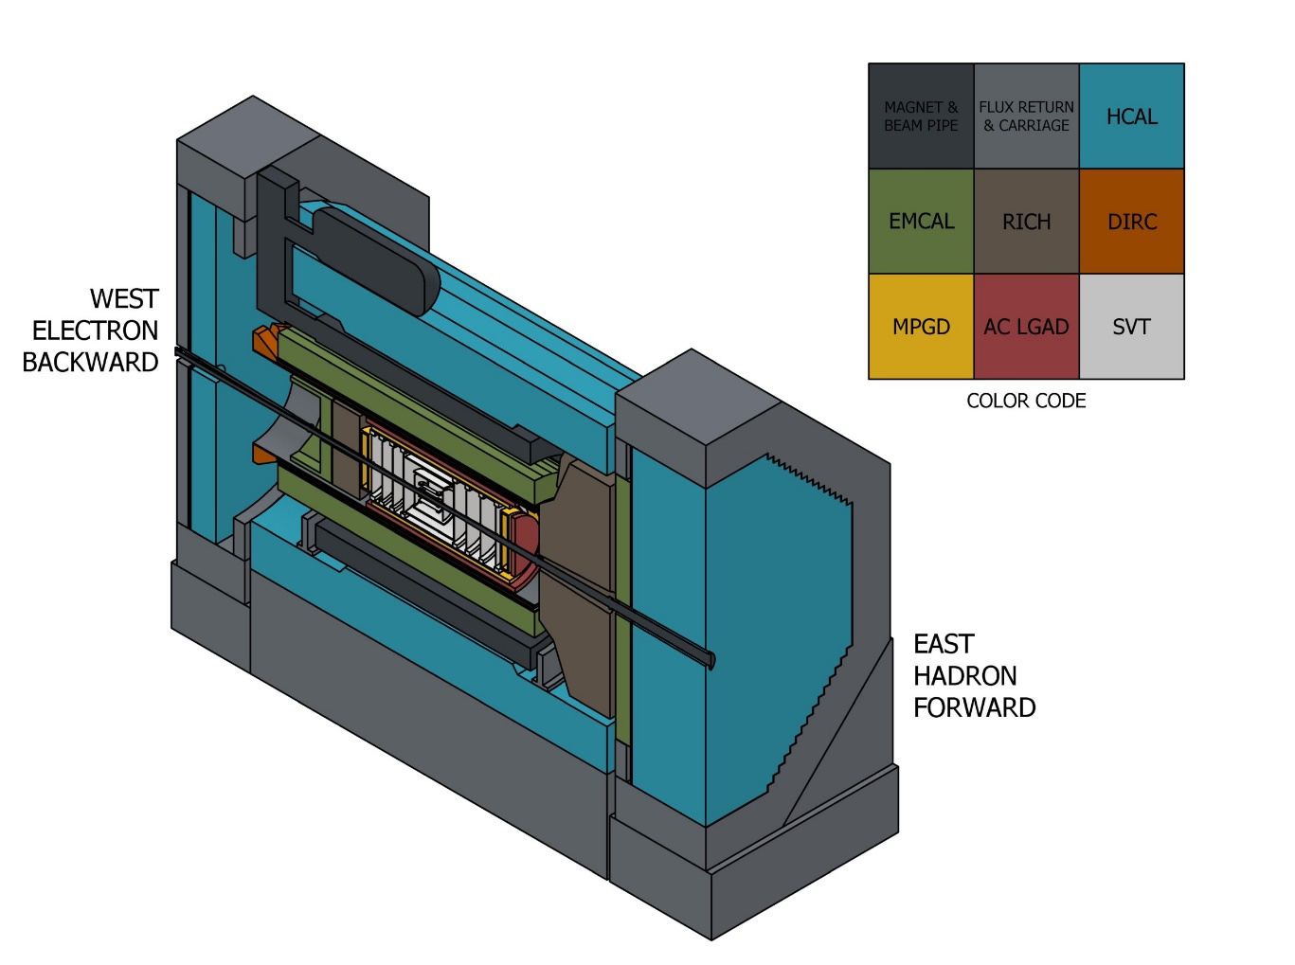
- Color Code Legend for Detector Components
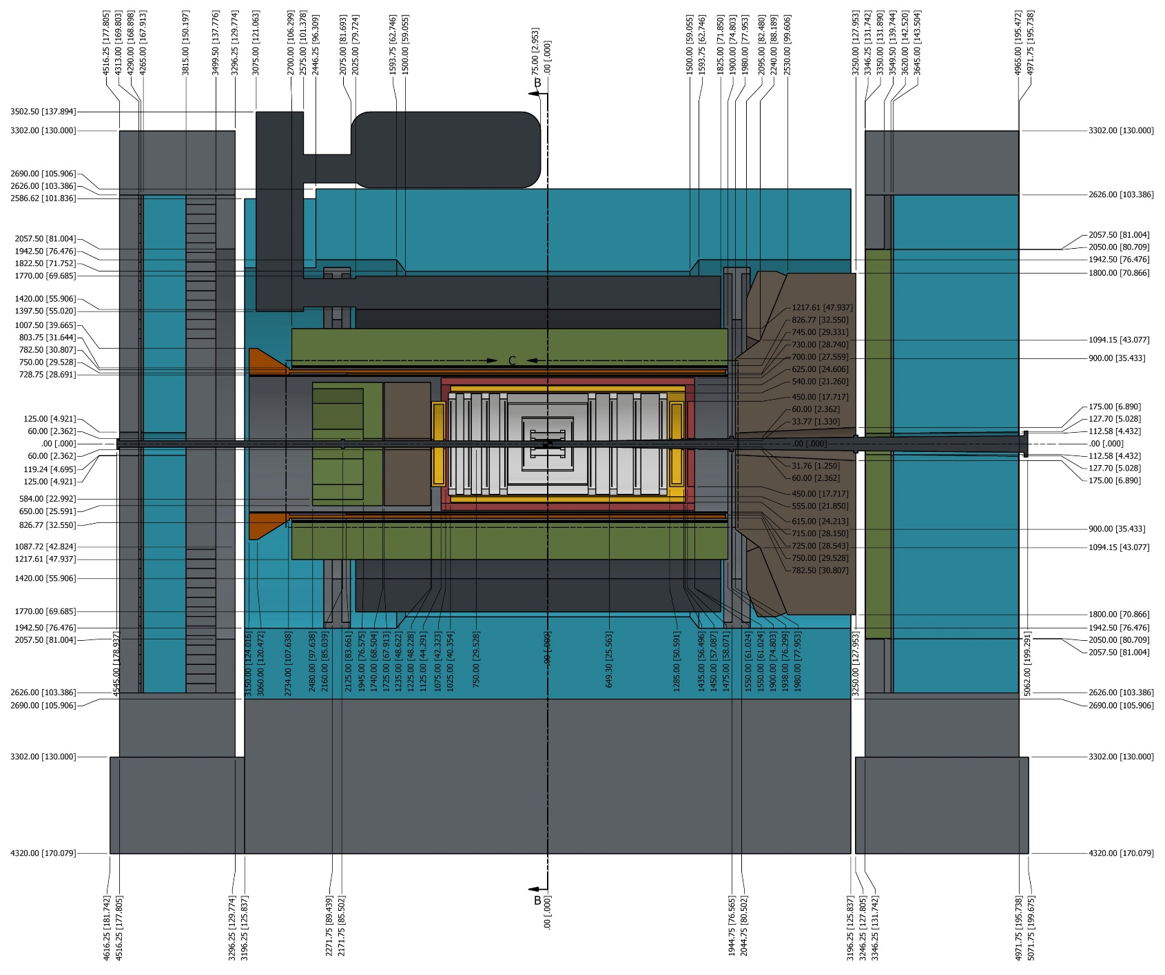
- Cross-sectional View of Detector Envelopes
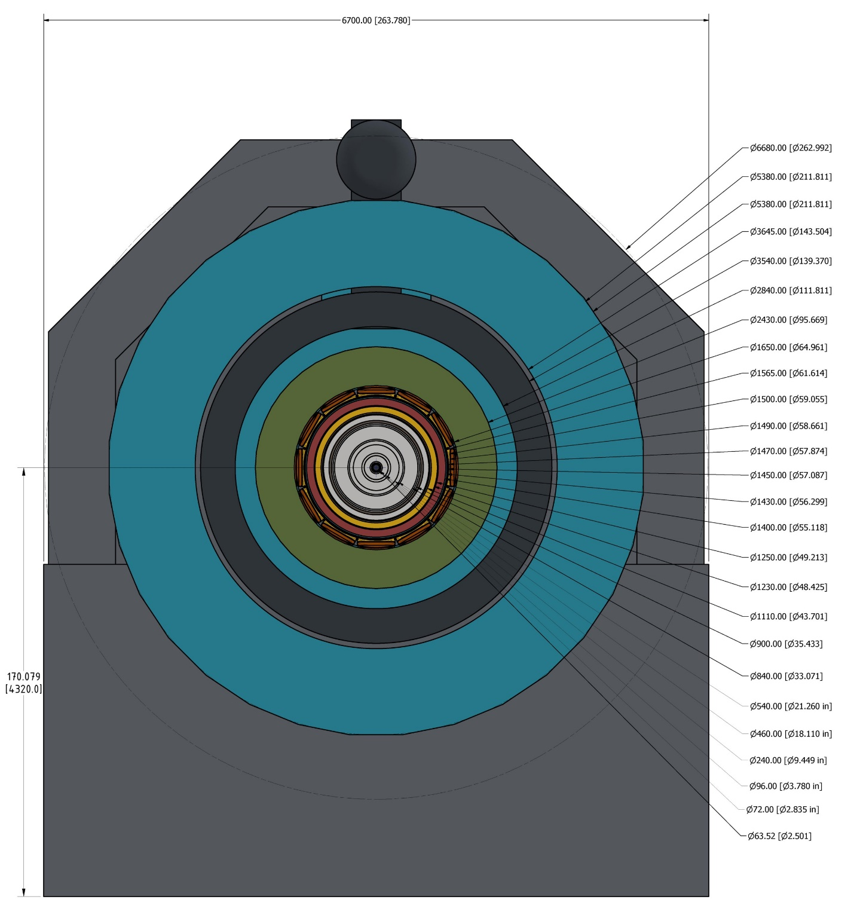
- End View of Detector Envelopes
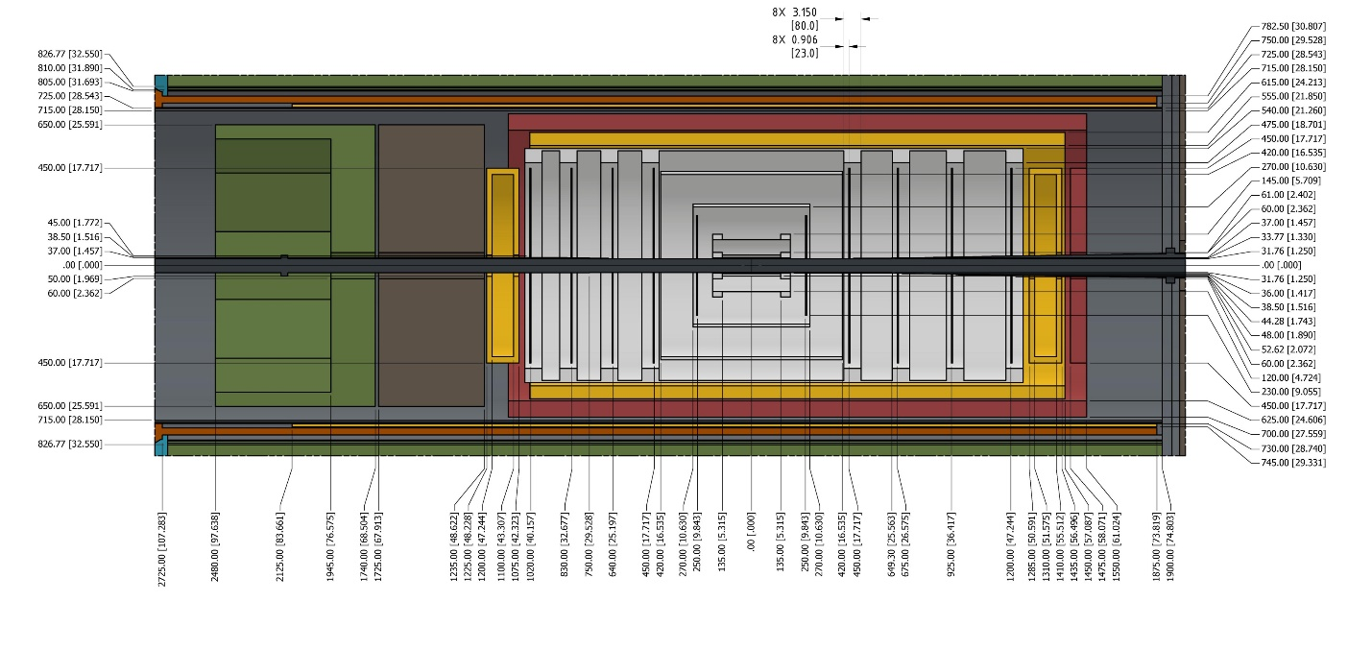
- Cross-sectional View of Internal Detector Subsystems

Organization
The interfaces in this document are grouped by sub-system as identified in the sub-system identifier. All interfaces between the Detector Infrastructure Systems and a related sub-system will be included in a single section. Entries within that section will be sorted by the interface identifier or WBS number, as appropriate.

Interface summary
This tables in this section provide a list of all interfaces that are defined within this document. The interfaces are grouped by sub-system/WBS. Each table has the following fields:
    - Section: the section number in this document where the interface is addressed.
    - WBS (1): the WBS number within the ICD reference system, unless the reference system is the owner.
    - WBS (2): the WBS number for the connected system.
    - ID: the interface identifier as defined in the Interface Requirement Document (IRD).
    - Name: the name of the interface as defined in the IRD.
    - Description: the description of the interface as defined in the IRD.
    - Owner: identifies the WBS number of the entity that is responsible for ensuring the interface is provided and that it meets validation/verification requirements.
- Detector Infrastructure Systems to BNL EH&S Indirect Support
Section | WBS1 | WBS2 | ID | Name | Description | Owner
4 |  |  |  |  | BNL EH&S Indirect Support
4.1 | 6.03.01.09 |  | I-DET-INF-INT.120 | ODH Calculation/Analysis | An oxygen deficiency hazard (ODH) analysis must be performed to determine the impacts and precautions that are necessary in the event of a cryogen leak. | 6.03.01.09.04
4.2 | 6.03.01.09 |  | I-DET-INF-INT.121 | ODH Detection/Alarm System | An ODH detection and alarm system must be installed that addresses any concerns identified in the ODH analysis. | 6.03.01.09.04

Detector Infrastructure Systems (DET-INF) to BNL EH&S Indirect Support (BNL-EHS)

I-DET-INF-INT.120 ODH Calculation/Analysis
- System 1: Detector Infrastructure and Utilities Integration (6.03.01.09.04)
- System 2: BNL EH&S Indirect Support (BNL-EHS)
- Type: ENV
- Description: An oxygen deficiency hazard (ODH) analysis must be performed to determine the impacts and precautions that are necessary in the event of a cryogen leak.
- Provider: Detector Infrastructure and Utilities Integration (6.03.01.09.04)
- Details: See details in the Detector Infrastructure Interface Control Document.
- Requirements: F-DET-INF.3,F-DET-INF.4
- References:

I-DET-INF-INT.121 ODH Detection/Alarm System
- System 1: Detector Infrastructure and Utilities Integration (6.03.01.09.04)
- System 2: BNL EH&S Indirect Support (BNL-EHS)
- Type: ENV
- Description: An ODH detection and alarm system must be installed that addresses any concerns identified in the ODH analysis.
- Provider: Detector Infrastructure and Utilities Integration (6.03.01.09.04)
- Details: See details in the Detector Infrastructure Interface Control Document.
- Requirements: G-DET-INF.3,G-DET-INF.4
- References:

Applicable Documents
List applicable documents considered to be part of this document. Applicable documents shall be obtained from the EIC SharePoint Document Center.

Detailed change Log
Revision | Date | Change

References
- doi:10.17226/25171., National Academies of Sciences, Engineering, and Medicine, "An Assessment of U.S.-Based Electron-Ion Collider Science", The National Academies Press, Washington, DC, 2018.
- EIC-ORG-PLN-010, Electron-Ion Collider L1 Requirements (Global Requirements Document)
- BNL-221006-2021-FORE, EIC Conceptual Design Report
- arXiv:2103.05419, Science Requirements and Detector Concepts for the Electron-Ion Collider: EIC Yellow Report
- EIC-SEG-PLN-016, Requirements Management Plan
- EIC-SEG-PLN-022, Systems Engineering Management Plan
- EIC-SEG-PLN-020, EIC Interface Management Plan

